Turkiye Offshore Racing Sports Club

13rd - 18th of, JULY 2024
TORC-AKPA Chemicals
“TURKISH NAVAL FORCES CUP”
53rd EDITION
INTERNATIONAL OFFSHORE YACHT RACE
“one race

two straits,Bosphorus & Dardanelles
three seas Marmara, Aegean & Mediterranean”

Notice of Race
13rd - 18th of, JULY 2024

Turkiye Offshore Racing Sports Club
Ataköy Marina, Sahil Yolu 34158, Bakırköy İstanbul
Phone: +90 (212) 560 5655 Fax: +90 (212) 560 5695
E-mail: tayk@tayk.org.tr Web site: www.tayk.org.tr

Race Officials are using a web-based program to assist with the management of this regatta. It provides electronic forms for such actions as scoring inquiries, protests, equipment substitutions, etc. And it provides for electronic communication with competitors if competitors have provided an email and/or telephone number accepting SMS. Competitors will be notified electronically of protest time limits, confirmation of a protest filing, scheduled hearing times, etc. This electronic system allows competitors to move freely about the event and remain in contact with relevant officials. And all competitors have electronic access to the scoring inquiries, jury decisions, etc.*
Notice: This electronic notice board is the Official Notice Board (ONB) for this regatta.

GENERAL INFORMATIONS
- Breaches of rules in the sailing instructions marked [NP] shall not be grounds for protests or request of redress by a yacht. This changes RRS 60.1 and 62.1(a)
- The notation ‘[DP]’ in a rule means that the penalty for a breach of the rule may, at the discretion of the International Jury, be less than disqualification. Guidelines for discretionary penalties are available on the World Sailing.
- Online Notice Board is available at. https://www.racingrulesofsailing.org/documents/7667/event?name=turkish-naval-forces-cup-53rd-edition-open-offshore-race

ORGANISING AUTHORITY
The organising authority of this event is Turkish Offshore Racing Club
  - Race Office will be located at:
    - Before the Race: Tezmarin Office, Kalamıs Istanbul
    - During the Race D-Marin Göcek Marina



- RULES
  - The Race will be governed by the rules as defined in The Racing Rules of Sailing (RRS 2021 - 2024). RRS 90.3(e) shall apply.
  - The latest version of the following rules will also apply:
    - The WS Equipment Rules of Sailing (ERS) 2021 – 2024.
    - The WS Offshore Special Regulations (OSR) for Category 3. When details of Special Regulations cannot be met the OA may accept an alternative.
    - IRC Rules, Parts A, B, C.
    - AMH Rules for multihulls
  - The WS Advertising Code,
  - Between 13 to 18 July 2024, from sunset until sunrise, Part B of the current International Regulations for Preventing Collisions at Sea (IRPCAS) shall apply, this changes RRS Part 2 of the RRS.
  - Notice of Race, TORC 2024 Cakabey Offshore Trophy NoR, Sailing Instructions, and their amendments.
  - If there is a conflict between the rules above, the Notice of Race, the Sailing Instructions and its amendments will be valid according to their date. This changes RRS 63.7.
  - YB Tracking System shall be used in the race.
  - The official language of the event will be English. If there is a conflict between texts, English text shall take precedence.
  - No national authority prescriptions will apply.
  - The Organizing Authority reserves the right to amend this Notice of Race. Amendments will be published on the Official Notice Board.
  - Additional changes to RRS may be specified in the SI.
  - Under World Sailing Development Rule DR21-01, change definition Start as follows:
Start: A boat starts when her hull has been entirely on the pre-start side of the starting line, and having complied with rule 30.1 if it applies, any part of her hull crosses the starting line from the pre-start side to the course side either (a) at or after her starting signal, or (b) during the last minute before her starting signal.
When a boat starts in accordance with item (b) of the definition Start, she may return to the pre-start side of the line to comply with item (a) of the definition of Start. If she does not, the starting penalty shall be 2% of her elapsed time added to it or at least 2 places, whichever is the greatest.
  - The nationality of a yacht shall be determined by the port registration of the country in which it is registered.
- INTERNATIONAL JURY
  - An international jury will be appointed for this race as per RRS Appendix N. Its decisions will be final as provided in RRS 70.5
- RACE FORMAT
  - The race is planned as a single race over multiple day.
- [NP] ELIGIBILITY
  - The race is open to all monohull & multihull sailing yachts with the below characteristics:
    - LH/LOA greater than or equal to eight (8) meters with,
    - A working inboard engine with sufficient fuel,
    - A valid 2024 IRC certificate for monohulls and AMH certificate for multihulls,
    - Having suitable equipment for the race and safety rules,
    - A life raft with capacity to hold the number of crew on board and shall be within its service period.
  - At least two (2) members of crew must have WS Offshore Personal Survival or TORC Sea Survival certificates and at least two (2) members of crew must have first aid certificates.
  - The race is open to all eligible yachts and sailors who comply with the World Sailing Eligibility Code.
  - All those registered are deemed to have accepted all the rules stated in the Notice of Race.
- CLASSES
  - This race is open for IRC class for monohulls and AMH class for multihulls only.
  - For yachts that need to obtain a certificate, or revalidate their certificate, the latest application deadline is 05th of July 2024, 1200 (local) hrs.
  - The TCC value on the IRC certificate will be used. The TCC (No Spinnaker) value will not be used.
  - The owner or skipper of the yacht shall be declared for using of “Primary” or “Secondary” IRC certificate during the registration. Otherwise, primary certificate shall be used.
- [NP] DIVISIONS and WARNING SIGNAL PENNANTS
- Division/Warning Signal Pennants will be as follows;
- IRC0 : TCC value 1.125 and above PINK Pennant
- IRC1 : TCC value between 1.050 and 1.124 YELLOW Pennant
- IRC2 : TCC value between 1.000 and 1.049 GREEN Pennant
- IRC3 : TCC value between 0.965 and 0.999 BLUE Pennant
- IRC4 : TCC value 0.964 and below ORANGE Pennant
  - Multihull class white pennant
  - (NP) Boats shall compete in the divisions specified and declared by the OC and may not request to race in another division or protest their class divisions.
  - (DP)Boats shall display their class/division pennants on their backstay or if they do not have a backstay, it will be displayed at a visible position aft of the boat, from their arrival to the starting area until they finish the race.
- ENTRY
  - Eligible yachts may enter by duly completing the Online Entry Form located at https://form.jotform.com/233483405915963 and www.tayk.org.tr or www.guneyyarisi.com latest by 01stof July 2024 1700 (local) hrs.
- ENTRY FEES
  - Entry fee shall be EUR400 (including payments to the TSF) and EUR200 for social events for each yacht.
  - Late entries will be accepted additional EUR100. Until 10th of July
  - Bank Account Details as follows:
  - Türkiye Açıkdeniz Yarış spor Kulübü, TEB (türkiye Ekonomi Bankası ) Çiftehavuzlar Branch IBAN: TR730003200000000105996133 / Swift Code: TEBUTRIS134
- CREW LIMITATION
  - All Turkish citizen competitors shall have a TSF license valid for 2024. There will be no temporary licenses.
  - Every change of a crewmember shall be declared via online (ONB), no later than one (1) DAY before the scheduled time of the warning signal. No verbal crew change declarations shall be permitted. In case a yacht is determined to have raced with an undeclared crewmember or has raced without the full declared crew list, the International Jury may choose to disqualify the yacht (DSQ).
  - The Person in Charge of the yacht shall be on board the yacht they have registered during the race. The Person in Charge of one yacht is not permitted to race on another yacht. Failure to comply with this rule is grounds for disqualification (DSQ) by the International Jury both for the Person in Charge’s yacht and the second yacht the Person in Charge races on.
  - IRC Rule 22.4.2 is deleted and replaced with: «the maximum number of crew on board shall be the Crew Number printed on her certificate. There is no weight limit». All crew members must be above the age of 18. Competitors below the age of eighteen (2005 and above) shall not be permitted in the race.
  - Members of the Press whose presence aboard is declared to the OC are not within these crew number limits.
- NUMBER OF RACES
  - One (1) offshore race is scheduled.
- RACE PROGRAMME
  - Online Pre-registration until 01st of July
  - Press Launch 08th of July Monday at1830 hrs. (local); Beşiktaş Naval Museum
  - Registration 08th and 09th July from 1000 to 1700 hrs.(local)
  - Skipper Briefing: 09th of July Tuesday, at1830 hrs. (local); Fenerbahce D/G Station Command Base.
  - Opening Ceremony: There will be a cocktail event for all crew members and other people associated with the organisation at 2000 hrs (local) in D/G Naval Social Facilities Fenerbahce
  - Training Race PRINCE ISLANDS RACE (only for registered yachts) 10th of July 2024 Wednesday,
FWS will be given at1200 hrs. (local)
  - Check-in & inspection: 10th to 12nd of July, IRC & Safety equipment inspection.
  - Tracking Beacon Inst.: 10th to 12nd of July, YB Tracking devices installation.
  - First Warning Signal: SATURDAY, 13rd of July 2024 at 1600 (local) hours.
  - Prize Giving Ceremony: 18th of July 2024, Thursday at 2000 (local) hours at the Göcek Dmarin Marina.
- START
  - The race will be started by using RRS 26, (five minutes)
  - All IRC & AMH divisions shall start at the same time. The signal flag will be the TORC pennant.
- RACE COURSE
  - FOR ALL IRC & AMH Divisions.
  - İSTANBUL, Tarabya START
  - ÇANAKKALE BOĞAZI DARDANELLES
  - MİDİLLİ (to port) LESVOS
  - SAKIZ ADASI (to port) CHIOS ISLAND
  - İKARIA ADASI (to port) IKARIA ISLAND
  - RODOS ADASI (to port) RHODES ISLAND
  - FETHİYE KÖFREZİ, Göcek Açıkları FİNİŞ
  - While navigating under sail through the Istanbul (Bosporus) and Çanakkale (Dardanelles) Straits, it should be noted that vessels in transit have priority; and warnings and instructions given by the Race Committee and the Maritime Traffic Control Stations should be adhered to.
  - (DP) Yachts shall adhere to the traffic separation scheme while navigating the Dardanelles Straits (APPENDIX A) Dardanelle Straits Mid-Point Coordinates and Areas Prohibited for Navigation.
  - Yachts shall stay away from natural obstructions and shallow waters within the racecourse.
  - It is prohibited to navigate between the Dardanelles “1915 Canakkale Koprusu/ Bridge” pillars and the mainland.
- [NP] DISTANCE
  - İstanbul – Göcek approximately 555 nautical miles.
- [NP] STARTING LINE
  - The starting line will be set between Tarabya and Beykoz Selvi Burnu Light on Istanbul Strait.
- [NP] FINISHING LINE
  - The finishing line shall be between a pole displaying a BLUE flag on the committee vessel /Navy Ship and the course side of a buoy. The positions of the race committee vessel and the buoy shall be as shown on the course charts.
- [NP] TIME LIMIT
  - FOR ALL CLASSES, the time limit is 18th of July 2024 1200hrs. (local)
- PENALTIES
  - A yacht that has broken any of the RRS Section 2 rules or Rule 31 (touching the mark) shall take a One-Turn Penalty. But if the Section 2 rule has been broken within the zone of a mark other than the starting mark, the yacht shall take a Two-Turn Penalty. (This changes RRS 44.1).
  - A yacht that breaches the line described by the Straits Mid-Point Coordinates during the Dardanelles Straits navigation and is clearly deriving a benefit from this situation shall incur a penalty as follows:
    - At first breach: Time penalty of 2% (Increasing the yacht’s elapsed time (ET) by 2%) or scoring penalty of two (2) places; the higher of these penalties shall be applied.
    - At the second breach: Time penalty of a total 4% (Increasing the yacht’s elapsed time (ET) by 4%) or Scoring penalty of total three (3) places; the higher of these penalties shall be applied.
    - At third breach, the yacht shall be penalized with the DSQ score.
- [NP] [DP] RACE CATEGORY AND SAFETY
  - The yachts shall have a life raft (specified within the NoR 4.1.(e), storm jib and all the equipment required for OSR Category 3 at all times during the race.
  - Yachts shall approach the Race Committee Vessel on the vessel’s starboard side at least fifteen (15) minutes prior to the warning signal and show their life raft, storm jib, and all crew shall be wearing life jackets and receive confirmation from the Committee Vessel.
  - The Race Committee may penalise a yacht for breach of safety regulations, obstruction of required checks in any way or for any other irregularities or breaches that the Committee observes.
  - All competing yachts shall be deemed to have complied with the Safety Equipment and other requirements specified Offshore Special Regulations for the race category. Responsibility for compliance rests solely with the Person in Charge of the yacht.
  - All safety equipment shall function properly and be regularly checked, cleaned, and serviced. If the safety equipment has an expiry date, it will not have exceeded its expiry date whilst racing.
  - All yachts need to have a suitable anchor with a suitable combination of chain and rope onboard whilst racing. The anchor shall not be carried on the stemhead and must be stowed in a suitable place in the anchor locker or within the yacht.
  - Race or Technical Committee reserves the right to conduct equipment inspection and event measurement without prior notice and without a lodged protest before the start of the race or after finishing.
  - All boats shall have on board navigational charts showing the appropriate areas that are not solely electronic.
  - A combined Lifejacket and Harness shall be worn when on deck: Between the hours of sunset and sunrise
- When alone on deck
- When reefed.
- When the true wind speed is 25 knots or above
- When the visibility is less than 1 nautical mile.
- [NP][DP] VHF COMMUNICATION
  - It is mandatory to have a VHF marine radio and to keep it on during the race. All yachts need to listen on VHF Channel 73, Channel 16 and during the Dardanelles crossing, the relevant Sector Channels unless otherwise instructed.
  - Except in an emergency, a yacht shall not make radio transmissions while racing.
  - Any WhatsApp communications for the purpose of fast communication between the Organising Authority or the Race Committee and the Persons in Charge of racing yachts will not be deemed to be outside help.
- RESTRICTIONS ON SAILS
  - All boats may have at most two (2) mainsails on board.
  - Except for storm and heavy weather sails, boats claiming a rating reduction for using a single roller furling headsail shall not have a second headsail on board.
  - For IRC Division Boats, IRC Rules for headsails will be applied. IRC Division boats that have not declared a spinnaker or have not declared a spinnaker pole despite having declared a symmetric/asymmetric spinnaker, may not use a spinnaker pole, whisker pole or other such equipment.
  - The mainsail may only be replaced while racing if the sail sustains enough damage to make it unusable. In such a case, the boat shall inform the Race Committee of the situation via VHF Channel 73 and by writing when they return ashore. The boat shall present their damaged mainsail to the Race Committee for inspection.
- [NP] [DP] DECLARATIONS
  - [DP] FINISH DECLARATION After finishing, every yacht is required to fully complete and submit to the Race Committee a Finish Declaration Form signed by the Person in Charge no later than the expiry of the protest time limit.
  - Person In Charge of a retiring yacht must promptly inform the Race Committee via VHF Channel 73 and must submit a written declaration as soon as possible.
  - When a yacht uses her engine to avoid collision, for rescue, or in a grave emergency, or uses its engine to charge its batteries without the turning the propeller or the shaft and continues to race, this needs to be declared in detail to the Race Committee no later than the expiry of the protest time limit.
  - Person In Charge of a yacht that has taken a Turn Penalty must submit their declaration forms to the Race Committee within the protest time limit via electronically or written. Yachts that fail to do so shall be deemed not having taken their Turn Penalties.
- [DP] HAUL-OUT RESTRICTIONS, DIVING EQUIPMENT AND PLASTIC POOLS
  - Without prior written permission of the Race or the Technical Committee, all yachts shall be afloat between the first race day and the protest time limit. Underwater breathing apparatus and plastic pools or their equivalent shall not be used around any participating yacht during this time period.
- BERTHING
  - Participating yachts may moor in;
    - “Setur Kalamış&Fenerbahçe Marina” from July 08th 2024 to start,
    - “D-Marin Göcek Marina”, from after her finishes to July 19th 2024 at 1000 (local) hrs. Otherwise D-Marine Marina may charge additional mooring fee.
  - Each yacht owner / lessee is responsible for ensuring the safety of his/her yacht and taking the yacht to a secure marina or responsibility of the participants and marinas accept no responsibility.
  - Both marinas must be supplied with the following documents on arrival of the yachts
    - Port Registration deed or Custom Yacht Registration Certificate or Certificate of tonnage.
    - Permit Range (Transit Log)
    - Insurance Policy
- PRIZES
  - Turkish Naval Forces Cup :
    - Best corrected time for IRC class (endorsed IRC certificate required)
  - Best corrected time for Multihull class.
  - Division Prizes : To top three of each division,
  - Line Honour : First Finish of the entire fleet
- RESPONSIBILITY
  - Offshore yacht racing can be dangerous. Competitors and support teams participate in the race entirely at their own risk. RRS 3, Decision to Race is “The responsibility for a yacht’s decision to participate in a race or to continue racing is hers alone”.
  - The Organising Authority, member of the Protest, Race Committees and all parties involved in the race organisation will not accept any liability for material damage or personal injury or death sustained in conjunction with or prior to, during, or after the race.
  - By participating in this race, which is governed by this Notice of Race, Notice of Race for the TORC 2024 CAKABEY Offshore Trophy and Instructions, all competitors, yacht owners and Persons in Charge:
    - Accept that the races will be governed by these rules,
    - Accept any penalties and other provisions of the race,
    - While reserving their right to appeal, accept that any event may have a final verdict within the rules,
    - That they will not sue in any court with regards to any such action or decision.
- TURKISH PERSONAL DATA PROTECTION LAW (TPDRL)
  - TORC will use the personal data provided by competitors only for the purposes of race organisation management in compliance with the Turkish Personal Data Protection Law (TPDRL). This data will be stored in compliance with TPDRL, will not be shared with any third parties or used for marketing purposes, or for any purpose other than for communicating information about this and subsequent events.
  - All competitors whose names are on the crew lists submitted by the yacht owner, helmsman or Person in Charge are assumed to have consented to this provision.
- CHOICE OF LAW AND JURISDICTION
  - This Notice of Race shall be governed by and construed in accordance with the law of Turkiye and each party agrees to submit to the exclusive jurisdiction of the Courts of Turkiye.
- RIGHTS TO USE NAME AND LIKENESS
  - By participating, a competitor automatically grants to the Organising Authority and the sponsors, the right in perpetuity, to make, use, show and publish, from time to time and at their discretion, any video or photograph or other material of the event in which the competitor participates without any compensation.
Published : 22 December 2023 – Time 1730hrs. (local)
Updated : 23 January 2024 – Time 1230hrs. (local)

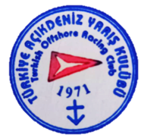
RACE ORGANISING AUTHORITY

APPENDIX A: RACE COURSE DETAILS

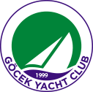


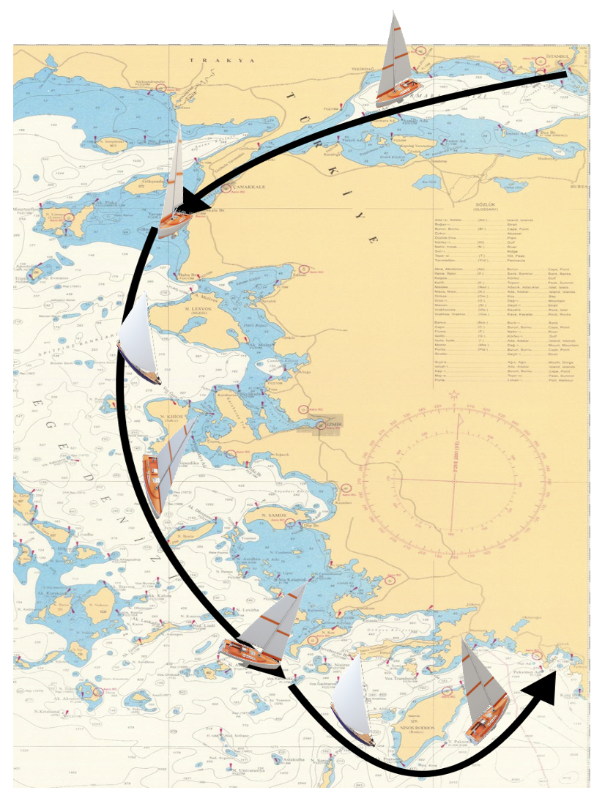

BOSPHORUS – MARMARA SEA & DARDANELLES

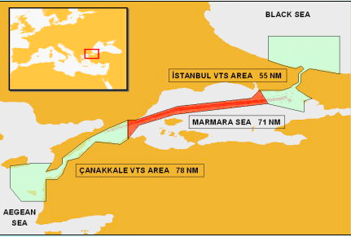
START: İstanbul Boğazı (Bosphorus)
Tarabya

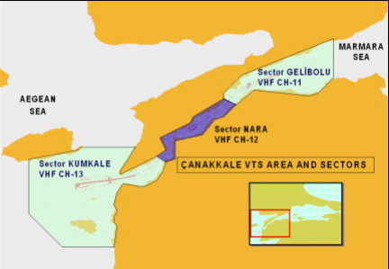

MID-POINT COORDINATES (WP) FOR THE DARDANELLES STRAITS
1: 40° 25’,940 N 026° 45’.130 E
2: 40° 23’.740 N 026° 41'.190 E
3: 40° 20’,260 N 026° 37’.730 E
4: 40° 13’,380 N 026° 27’,730 E
5: 40° 12’,100 N 026° 23’,440 E
6: 40° 11’,585 N 026° 22’,845 E
7: 40° 08’.960 N 026° 23’.270 E
8: 40° 08’.070 N 026° 22’.960 E
9: 40° 04’.240 N 026° 18’.450 E
10: 40° 02’.590 N 026° 15’.250 E
11: 40° 01’.320 N 026° 09’.350 E
12: 40° 00’.310 N 026° 00’.190 E
13: 39° 58’.850 N 025° 57’.680 E
The GPS coordinates for the mid-point line are listed above.

MIDILLI (LESVOS) & SAKIZ (CHIOS) AND IKARIA ISLANDS to Port
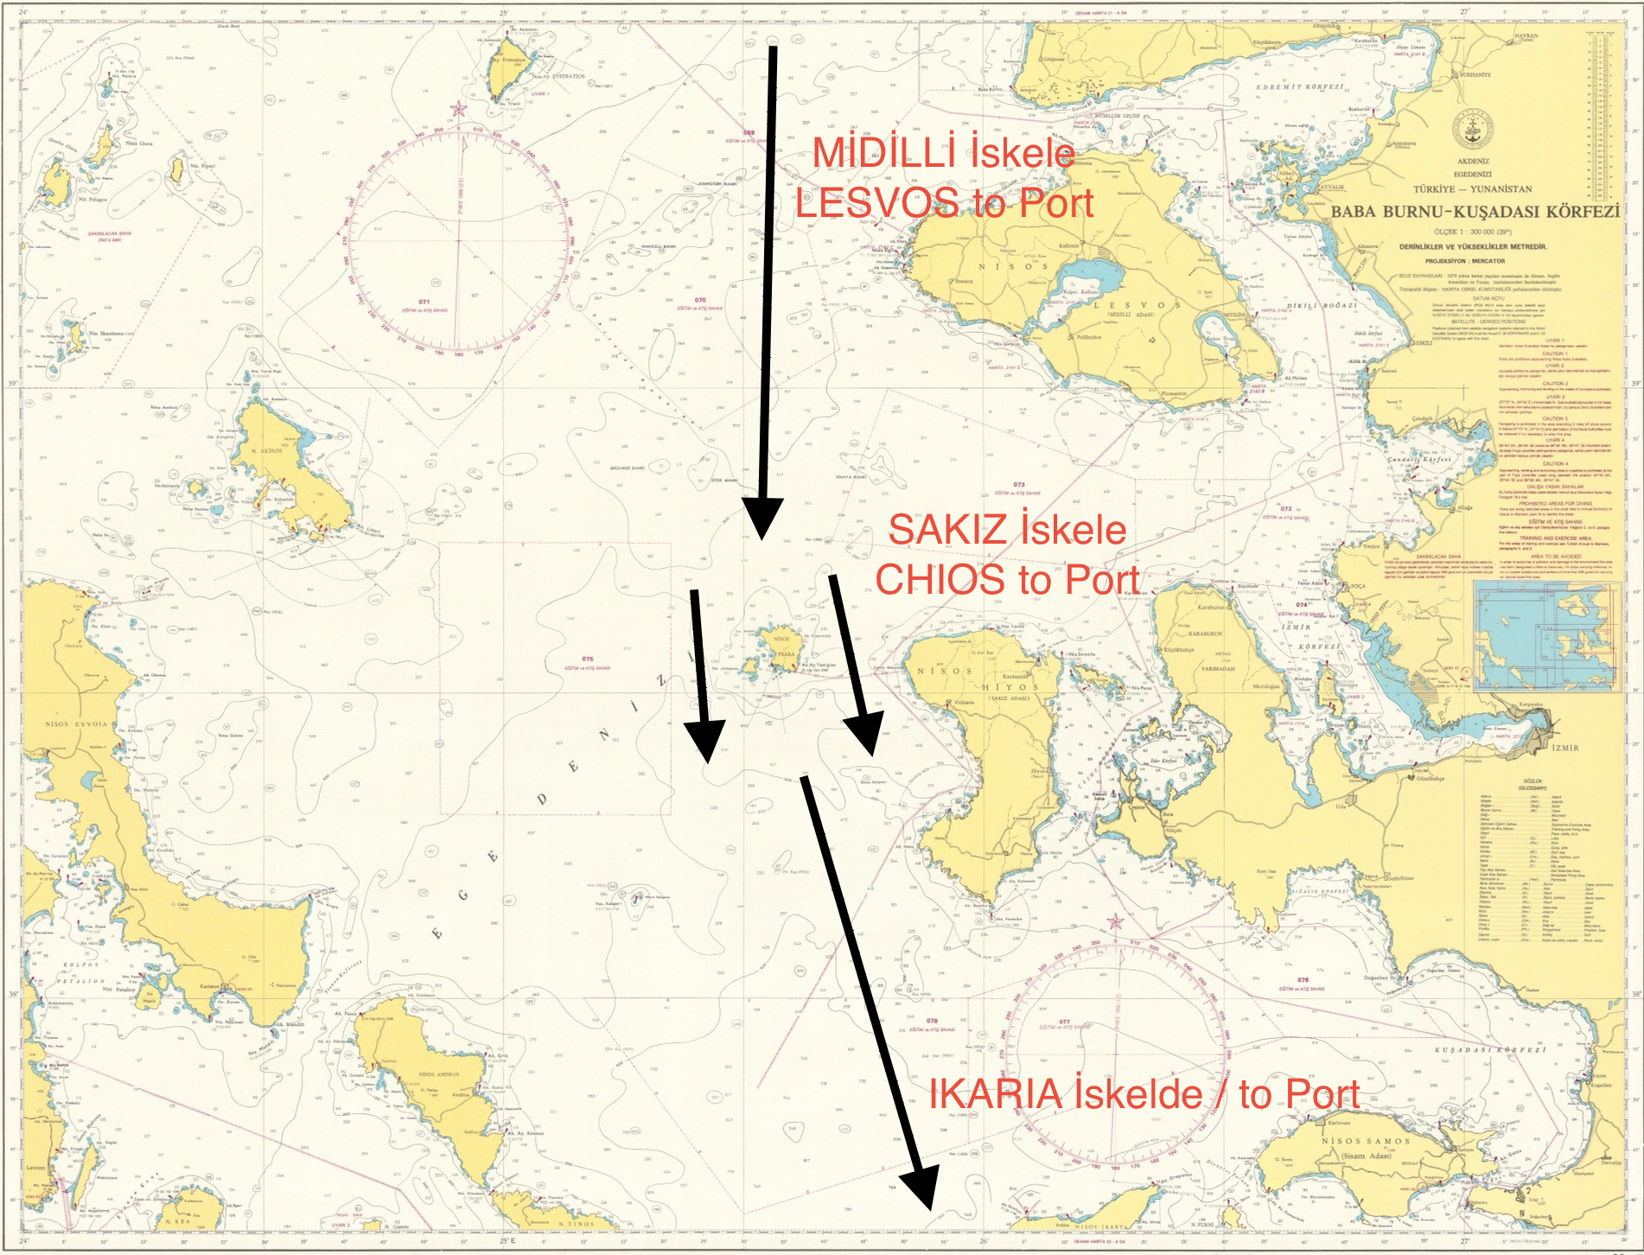

RHODES ISLAND to Port
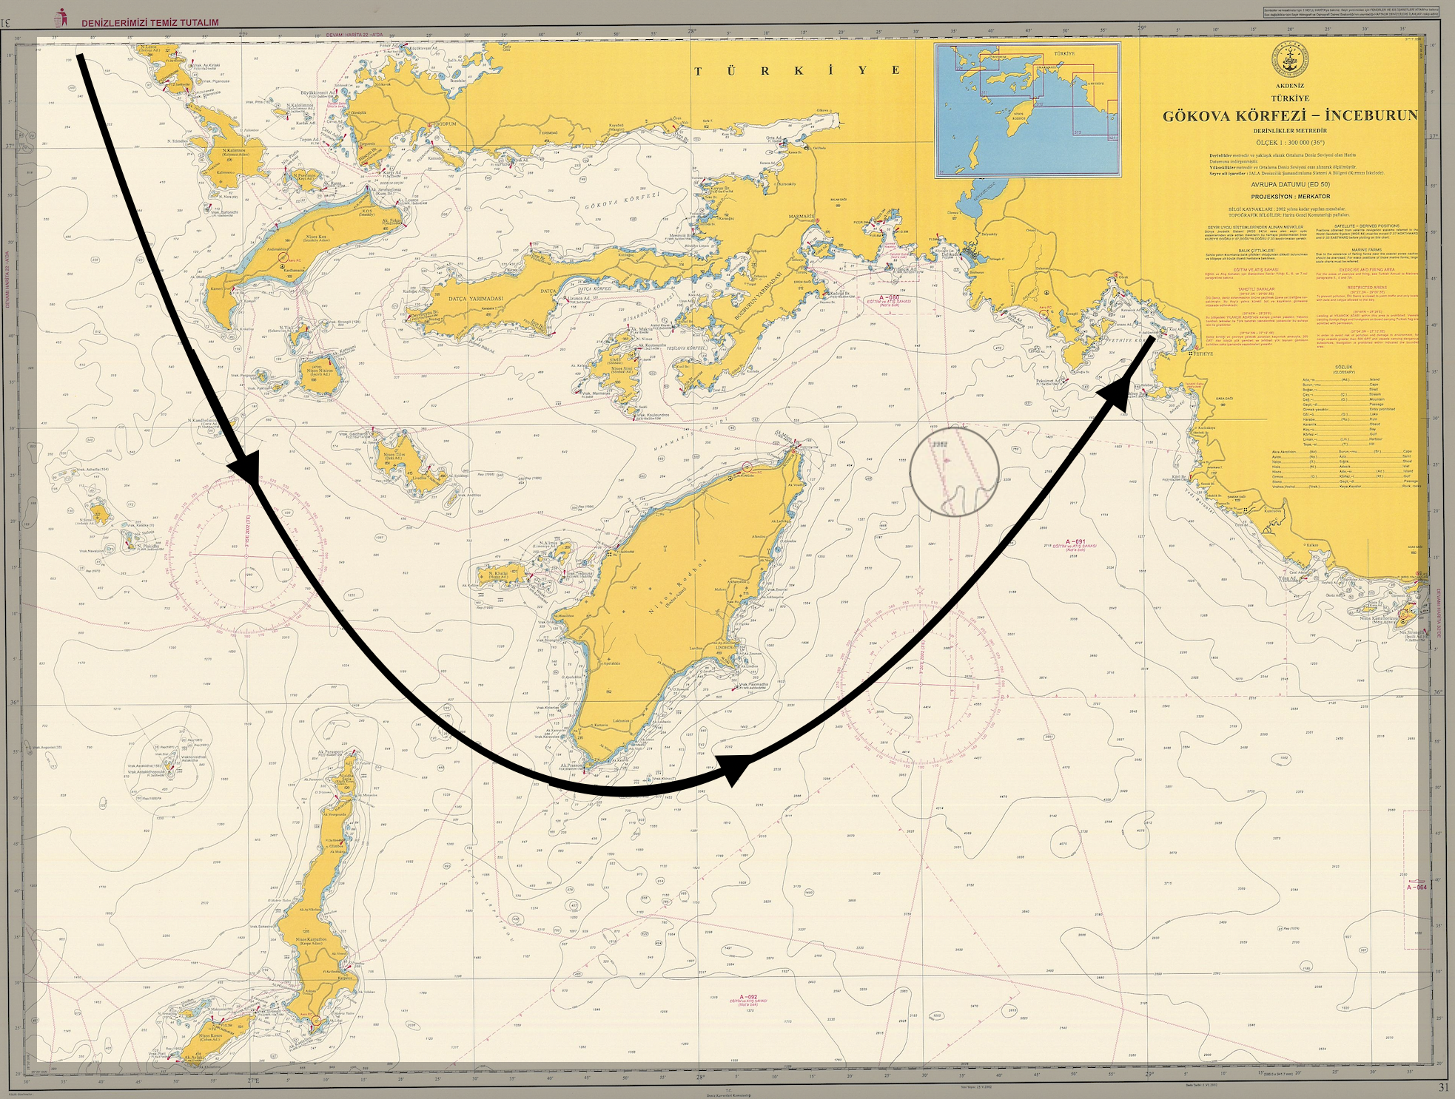

FINISING LINE WILL BE SET AT FETHIYE GULF (ANCHORED NAVY SHIP AND THE FINISING MARK )
(KIZILADA AND KATRANCIK ISLAND)
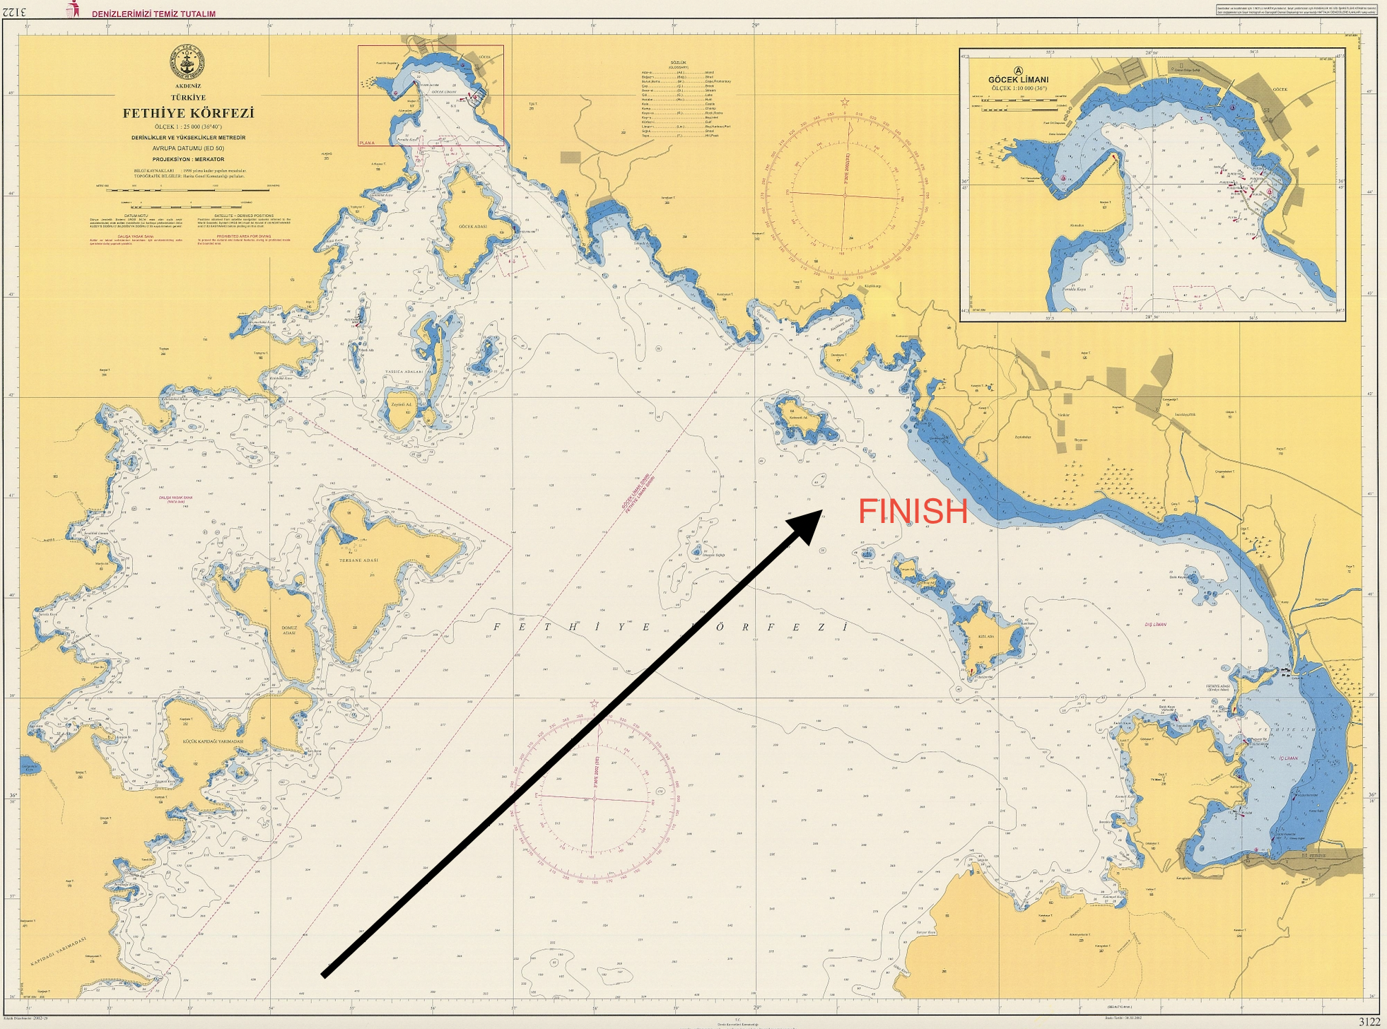

Links;

Online Pre-Registration
https://form.jotform.com/233483405915963

Turkish Sailing Federation
https://www.tyf.org.tr

Turkish Offshore Racing Sports Club
https://www.tayk.org.tr

Beşiktaş Naval Museum
https://www.turkishmuseums.com/museum/detail/22321-istanbul-naval-museum/22321/4

Setur Kalamış Marina
https://www.seturmarinas.com/

Dmarin Göcek Marina
https://www.d-marin.com/tr/marinalar/gocek/kapasite-ve-hizmetle/

